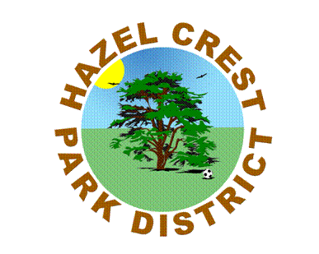
Summer Basketball Program
Hazel Crest Park District & In The Paint Basketball
Outdoor or indoor summer hoops program will focus on skills development & competitive games. Youth are divided into ages and skill levels where conditioning, concentrated skills and competitive 5 on 5 scrimmages & games will take place.
 Session 1 June 9th—June 27th
Session 2 June 30th---July 18th
Session 3 July 21st---August 8th
Daytime option: 9 am to 11 am
Program held on Mon-Wed & Thurs (outdoor court)
Residents $109 non Residents $119
Evening option: 6 pm to 7:30 pm
Program held on Tuesday & Thursday evenings (gym)
Residents $109 Non-Residents $119
SIGN UP TODAY AT THE FRONT DESK!!!

